STATE OF SOUTH CAROLINA | ) | IN THE COURT OF GENERAL SESSIONS
 | ) | EIGHTH JUDICIAL CIRCUIT
COUNTY OF LAURENS | ) | Case No.:  MOTION TO CONTINUE TRIAL
 | ) | Case No.:  MOTION TO CONTINUE TRIAL
The State of South Carolina, | )  ) | Case No.:  MOTION TO CONTINUE TRIAL
Plaintiff, | )  )  )  )  )  ) | Case No.:  MOTION TO CONTINUE TRIAL
v. | )  )
Lutavious Elmore,  Defendant. | )  )  )  )

On June 4, 2020, Defense Counsel met with the prosecution team and the Court in chambers. During this meeting Defense Counsel stated that Defendant’s case would be a good case to go forward the week of August 3, 2020. Ultimately the Court agreed to Defense Counsel’s request, and arranged for the above captioned case to be the test trial for COVID procedures. However, as more information has come to light about the impact COVID-19 will have on our state, Defense Counsel would be remise if they did not alter course and ask for a continuance to protect the rights of Defendant.
On June 4, 2020, our state was full of optimism. Much of the state had just started to come out after two months of quarantine. In Laurens County there were only 76 confirmed cases and 4 confirmed deaths. Around this time many state and federal leaders were focused on reopening. Like many of our government leaders, Defense Counsel was optimistic that our State had COVID-19 under control. However, Defense Counsel was wrong.
Since June 4, the total number of cases in Laurens County has increased by nearly 1000 cases and tragically 23 citizens of Laurens County have now died from COVID-19. The following is a chart showing the increase of COVID-19 in Laurens County:
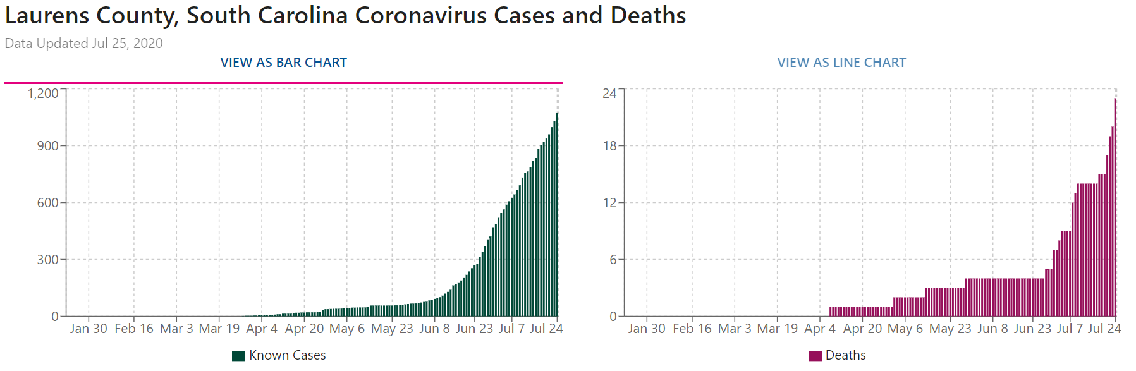
(Available at https://usafacts.org/visualizations/coronavirus-covid-19-spread-map/state/south-carolina/county/laurens-county). In other words more than 1 in every 68 people in Laurens County have tested positive for COVID-19. This does not account for the number of people who have not yet been confirmed. SCDHEC estimates that the actual number of COVID-19 cases in Laurens County as 7,779 or approximately 11 percent of the population. (See Exhibit A).
Although Defense Counsel recognizes and appreciates all the work this Court and the Court staff has done to implement safeguards to reduce the risk of COVID-19 spread during this trial, the uncontrolled spread of COVID-19 during the past two months has lead Defense Counsel to re-examine the propriety of proceeding forward on August 3, 2020.
Defendant objects to going forward based on the following:
- The COVID-19 conditions as well as the safety procedures will be coercive in that it will result in undue pressure to reach a consensus.
“Any criminal defendant … being tried by a jury is entitled to the uncoerced verdict of that body.” Lowenfield v. Phelps, 484 U.S. 231, 241, 108 S. Ct. 546, 552 (1988). This is guaranteed by both the South Carolina Constitution and the United States Constitution. See Constitution of the United States of America, Amendments VI and XIV, see also Constitution of South Carolina Article 1, Sections 3 and 14.
After what is surely to be several days of trial wearing a mask, the jury in this case will retire to a small jury room where they will be required to continue to wear a mask while deliberating. Each of the 12 jurors will be required to stay in close contact with other jurors. Some jurors may feel uncomfortable wearing a mask and think it is unnecessary. Whereas others will likely fear for their safety due to the forced close contact with others. These factors will have a chilling effect on the debate during deliberations that is essential to produce a fair trial.
- The trial is a risk to the safety of all people in the courtroom.
On Saturday, DHEC announced 74 newly reported deaths in South Carolina. Two of those deaths were citizens of Laurens County. There have been several people who work in the Eighth Judicial circuit’s courts who have tested positive for COVID-19.
As much as defense counsel would like to think he is invincible, he is not. COVID-19 is a serious health risk to the people in the courtroom for the trial of this case as well as the jurors. Despite having low numbers for the first couple of months of the pandemic, South Carolina is currently the state with the eleventh highest per capita number of confirmed positive cases. See CDC website (available at https://www.cdc.gov/covid-data-tracker/#cases).
While juries are often said to be a cross-section of the community. It may be a bad idea to gather that cross-section together until the number of COVID-19 cases begin to decrease.
- The defense team’s investigation has been slowed by COVID-19.
Criminal defendant’s has a Sixth Amendment right to effective assistance of counsel. In order to guarantee that right "[a] criminal defense attorney has the duty to conduct a reasonable investigation to discover all reasonably available mitigation evidence and all reasonably available evidence tending to rebut any aggravating evidence introduced by the State."). See McKnight v. State, 378 S.C. 33, 46, 661 S.E.2d 354, 360 (2008).
Although Defense Counsel did previously indicate they were prepared to go forward with this case, that was based on information we had at the time. In any case, as an attorney learns more about the case in preparation for trial, the need for further investigation may arise. Defense Counsel’s investigator is at high risk of serious complications if he were to contract COVID-19. As such, he has been limiting his “in the field” work. This has hindered the defense team in fully investigating the case.
Defendant seeks a continuance until the COVID-19 numbers lower where it will be safe to conduct “in field” investigations.
Respectfully Submitted,

s/ Tristan M. Shaffer
Tristan M. Shaffer (SC Bar 77565)
Attorney for Defendant

July 27, 2020

